Name: Qaseh Azalea

Class: 1K4

Title: SQL EXERCISE, library database

Date: 18 DECEMBER 2024

### CREATING A BOOKS TABLE

#### 1. Create Database

SQL COMMAND

CREATE DATABASE books_library;





#### 2. Create The books table

SQL COMMAND

CREATE TABLE books_borrowed (

book_id INT PRIMARY KEY AUTO_INCREMENT,

title VARCHAR(255) NOT NULL,

author VARCHAR(255) NOT NULL,

borrowed_date DATE NOT NULL

);

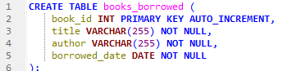



### REQUIRED OPERATIONS

#### 3. Data Entry/ Insert Sample Data

SQL COMMAND

INSERT INTO books (title, author, borrowed_date)

VALUES

('The Shadow of the Wind', 'Carlos Ruiz Zafón', '2024-01-22'),

('The Ocean at the End of the Lane', 'Neil Gaiman', '2024-02-18'),

('The Name of the Wind', 'Patrick Rothfuss', '2024-03-11'),

('Hard-Boiled Wonderland and the End of the World', 'Haruki Murakami', '2024-04-05'),

('The Left Hand of Darkness', 'Ursula K. Le Guin', '2024-05-17');

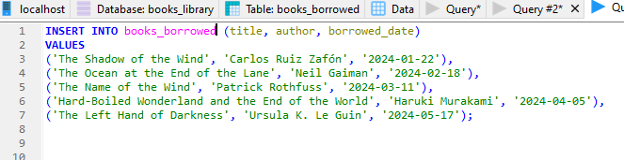

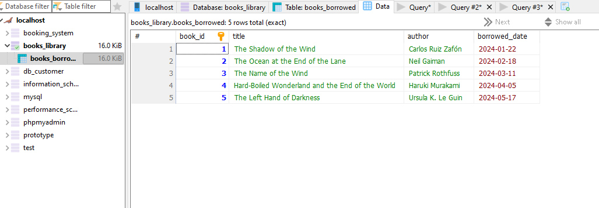

#### 4. BASIC QUERIES

1. SQL COMMAND

SQL COMMAND

SELECT * FROM books_borrowed;

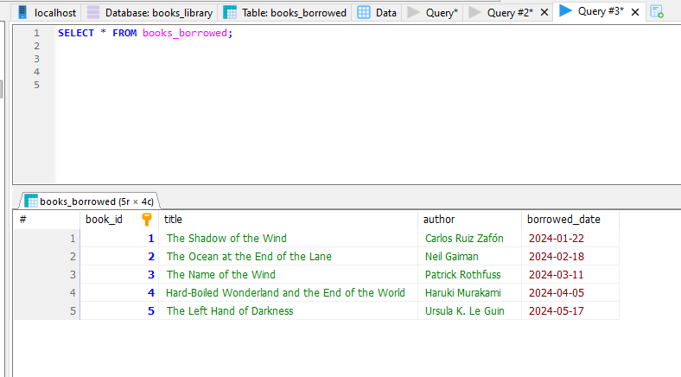

##### Find books by author

SQL COMMAND

SELECT * FROM books_borrowed WHERE author = ‘Haruki Murakami’;

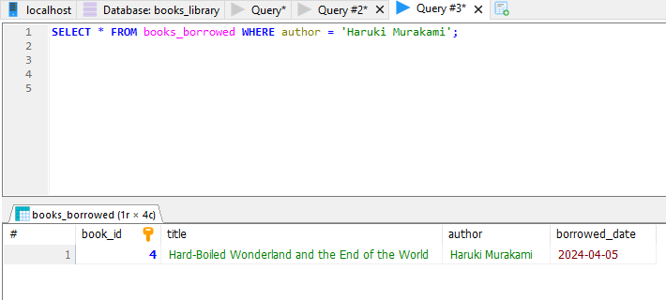

##### Find books borrowed on a specific date

SQL COMMAND

SELECT * FROM books_borrowed WHERE borrowed_date = ‘2024-02-18’;

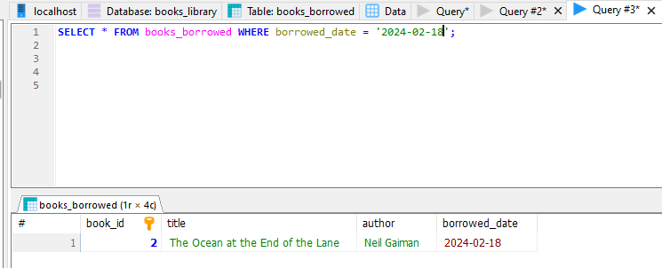

##### Find books borrowed after a certain date

SQL COMMAND

SELECT * FROM books_borrowed WHERE borrowed_date > ‘2024-02-18’;

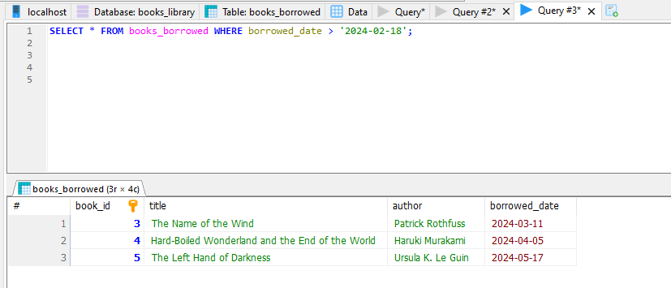

#### 5. DATA MANIPULATION

##### Update borrowed_date

SQL COMMAND

UPDATE `books_borrowed` SET `book_id`=2, `title`='The Ocean at the End of the Lane', `author`='Neil Gaiman', `borrowed_date`='2024-08-30'

WHERE `book_id`=2;



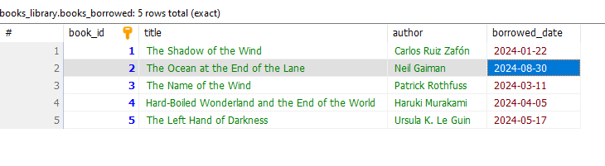

##### Delete a book

SQL COMMAND

DELETE FROM `books_borrowed` WHERE `book_id`=3;

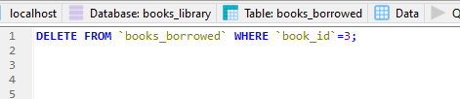

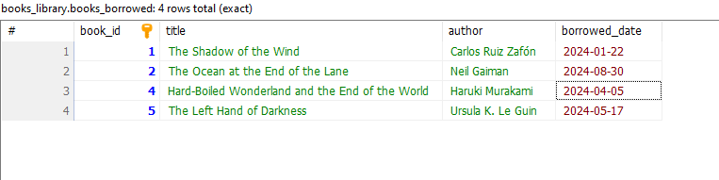

##### Re-add a deleted book

SQL COMMAND

INSERT INTO `books_borrowed` (`book_id`, `title`, `author`, `borrowed_date`)

VALUES (3, 'The Name of the Wind', 'Patrick Rothfuss', '2024-03-11');

